GRADE 7 ACCELERATED · UNIT 2 · ASSESSMENT
Real Numbers and Roots
34 points ANSWER KEY

Show your work. Circle your final answer.
1. Locating Real Numbers on a Number Line | 7 points

1. A number line is shown. Give the letter of the point that is closest to each value. | 3 points

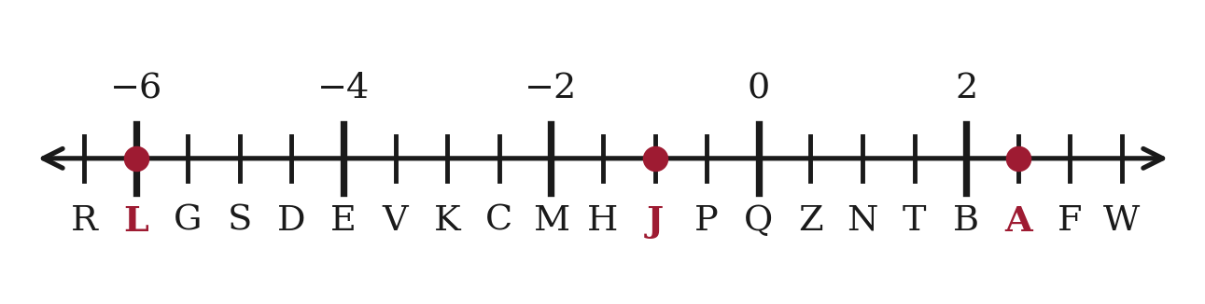
a. 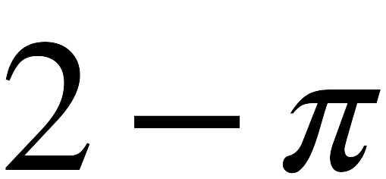

Point J (1)
2 − π ≈ 2 − 3.14 = −1.14. H is at −1.5 and J is at −1, so J is nearer — 0.14 away against H's 0.36. Any π from 2.75 to 3.25 gives J.

b. 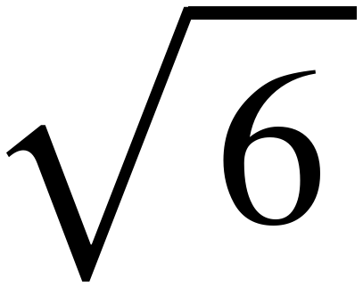

Point A (1)
6 is between the perfect squares 4 and 9 and nearer 4, so √6 ≈ 2.4. A is at 2.5.

c. 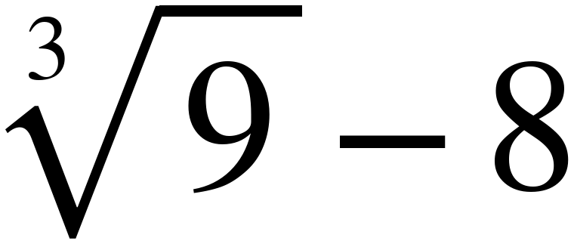

Point L (1)
9 sits just above the cube 8, so ∛9 ≈ 2.1 and 2.1 − 8 = −5.9. L is at −6.

Scoring: One point each for a, b and c = 3 points.
2. For each value, write the two consecutive integers it lies between, the integer it is closer to, and the comparison you used. | 4 points

Value | Lies between | Closer to | How you know
a. 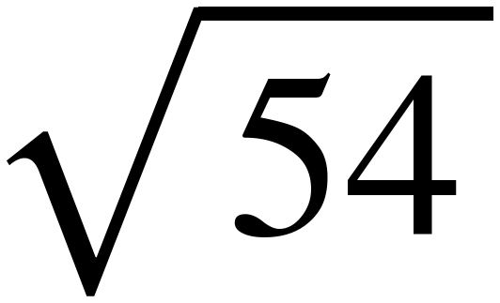 | 7 and 8 (1) | 7 | 49 < 54 < 64
b. 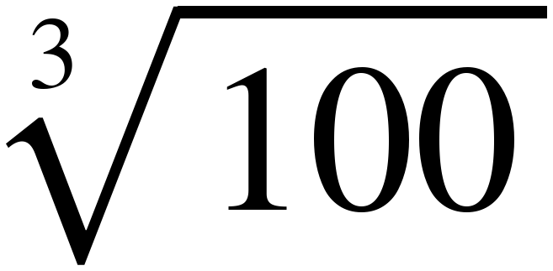 | 4 and 5 (1) | 5 | 64 < 100 < 125
c. 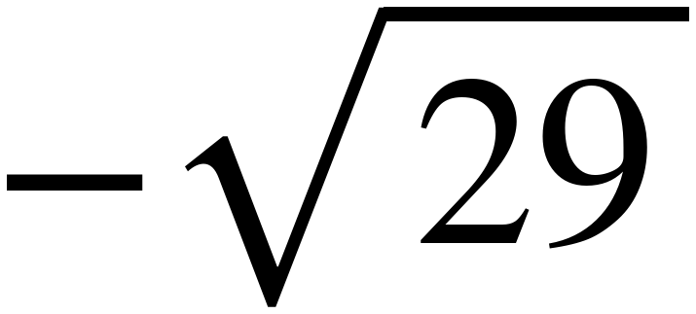 | −6 and −5 (1) | −5 | 25 < 29 < 36
d. 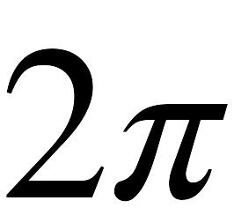 | 6 and 7 (1) | 6 | π ≈ 3.14

a: 49 and 64 are the perfect squares either side of 54, and 54 is nearer 49. b: 64 and 125 are the cubes either side of 100, and 100 is nearer 125. c: 25 < 29 < 36 and 29 is nearer 25, so √29 ≈ 5.4 and −√29 ≈ −5.4 — the closer integer is −5, not −6. d: 2π ≈ 6.28, and the comparison is π itself.
Scoring: One point per row = 4 points. The bracket, the closer integer and the comparison are one answer; all three have to be right. Accept any correct statement of the comparison — “between 49 and 64”, “7² and 8²”, “49 < 54 < 64” all earn it.
2. Roots and the Equations They Solve | 11 points

3. Write every value that makes each statement true. | 4 points

a. 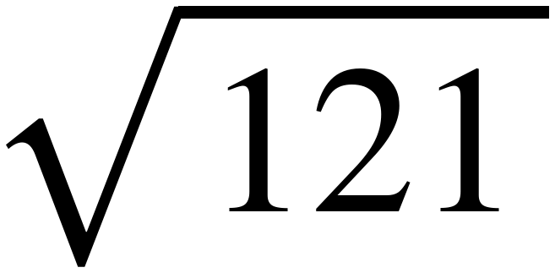 =

11 (1)
The radical sign asks for the principal root — the one that is never negative. 11 only.

b. If 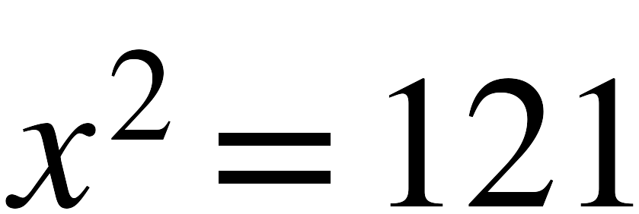, then x =

11 and −11 (1)
The equation asks for every number whose square is 121. Both values are required for the point.

c. 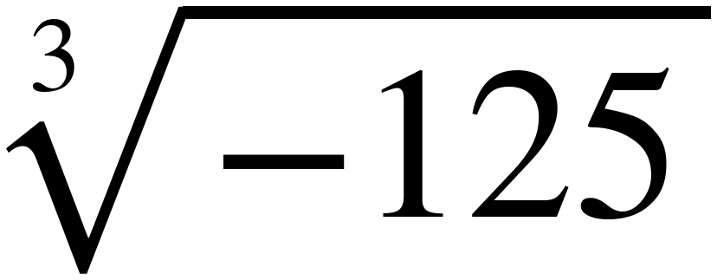 =

−5 (1)
Every real number has exactly one cube root. (−5)³ = −125.

d. If 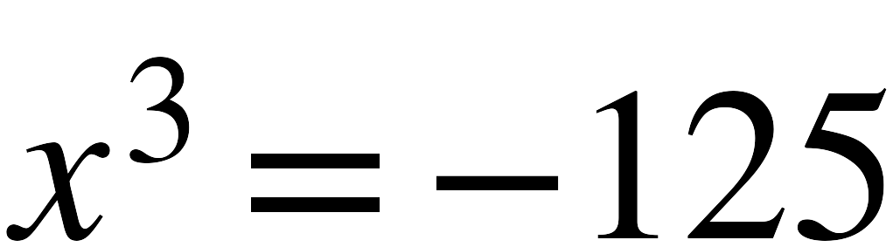, then x =

−5 (1)
One solution, the same value as part c. That is the difference between squares and cubes.

Scoring: One point each for a to d = 4 points. ±11 in part a is wrong: the radical sign names one number.
4. For each equation, select all of the solutions. | 4 points

 | 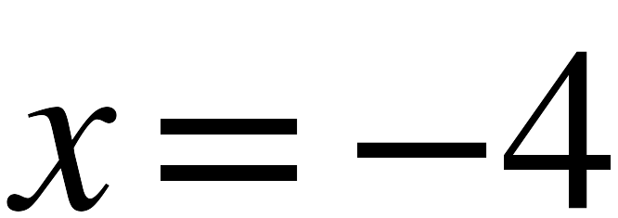 | 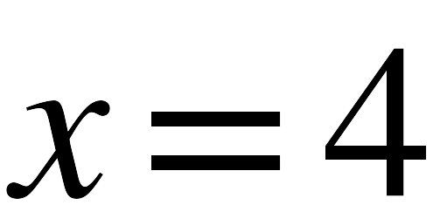 | 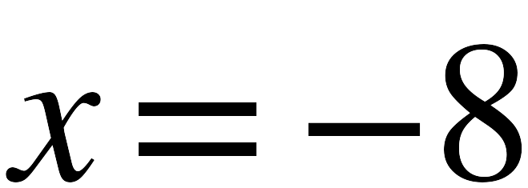 | 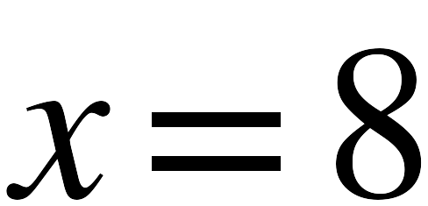 | no real solutions
a. 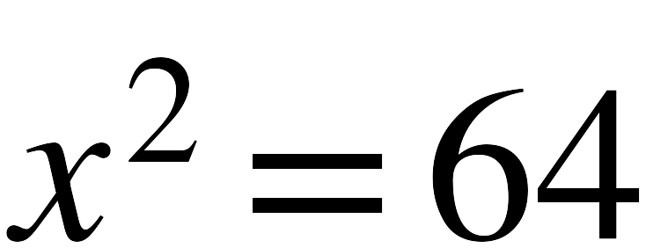 (1) |  |  | 
b. 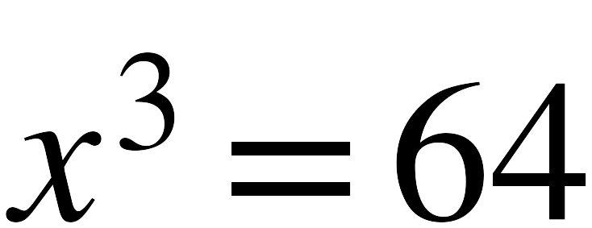 (1)
c. 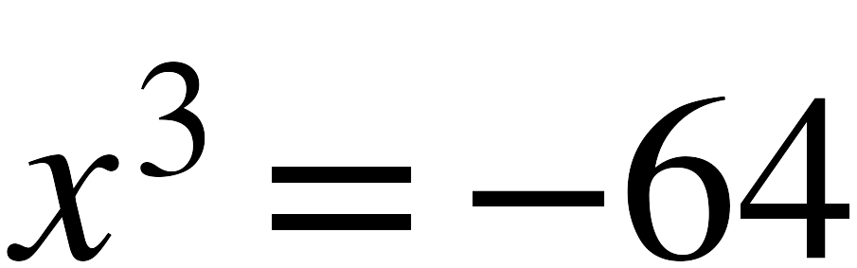 (1)
d. 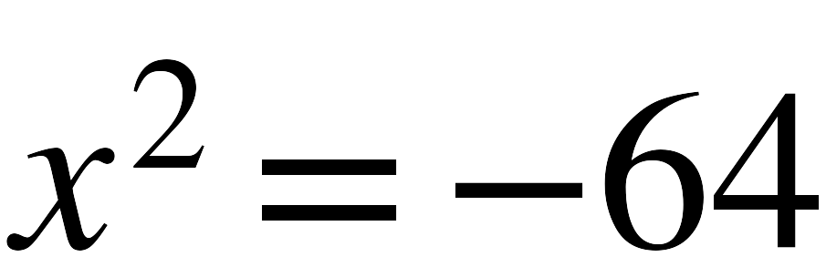 (1)

a: (−8)² and 8² are both 64 — both boxes are required for that row's point. b: 4³ = 64 only. c: (−4)³ = −64 only. d: no real number squares to a negative. Rows b and c are the pair worth reading together.
Scoring: One point per row = 4 points. A row is right or it is not; every box in it has to be correct.
5. Complete each statement. | 3 points

a. When x is any real number other than 0 and it is multiplied by itself, the result will

 |  always |  sometimes | never

be a
 | positive | negative

value. (1) both blanks together
b. Therefore, equations in the form 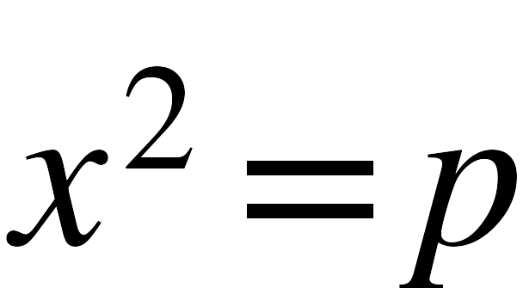 , where p is a whole number greater than 0, will have

 | only one solution. | two solutions. | three solutions.

(1)
c. How many solutions does 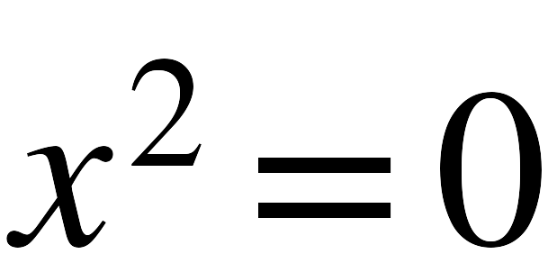 have?

Exactly one solution: x = 0. (1)
This is the one whole number part b has to exclude. 0 × 0 = 0, and nothing else squares to 0.
Scoring: One point each for a, b and c = 3 points. Part a is one point for both of its blanks.
3. Ordering and Comparing Real Numbers | 10 points

6. List the numbers below from least to greatest. | 1 point

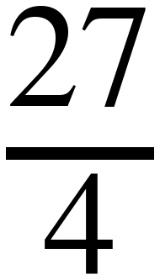 , 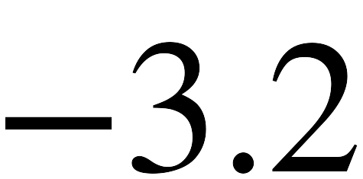 , 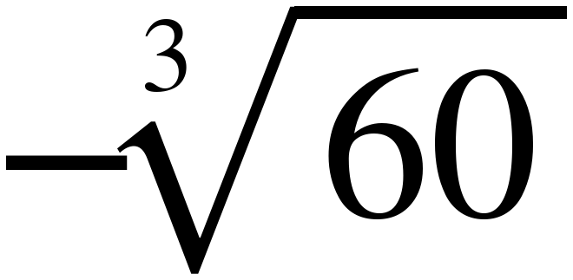 , 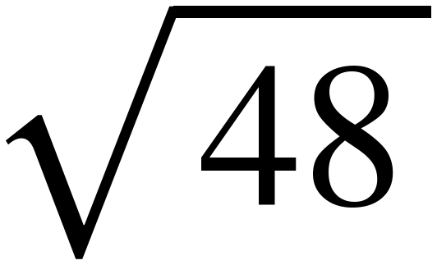 , 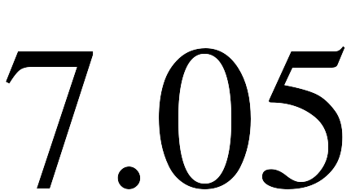
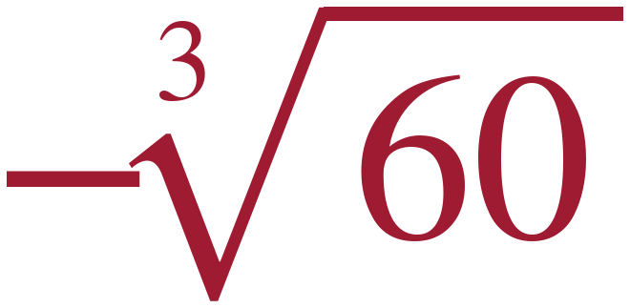 | 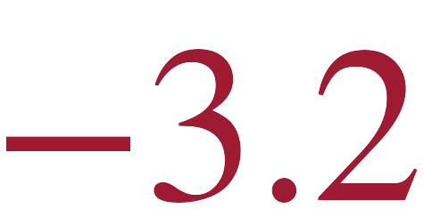 | 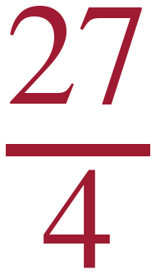 | 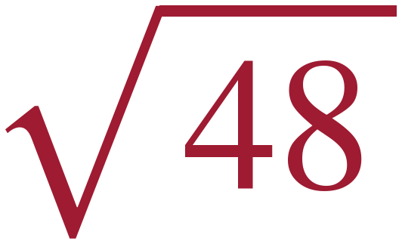 | 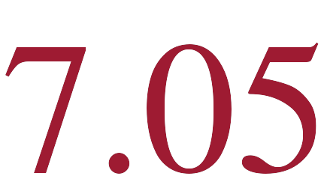

−∛60 ≈ −3.9 (60 sits between the cubes 27 and 64), then −3.2, then 27/4 = 6.75, then √48 ≈ 6.9 (48 is just under 49), then 7.05.
Scoring: One point for the list = 1 point. All five in the right order, or nothing.
7. Compare each pair. Select <, > or =. | 5 points

a. (1) | 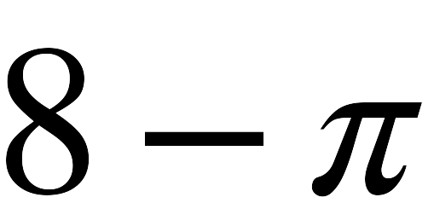 | < > = | 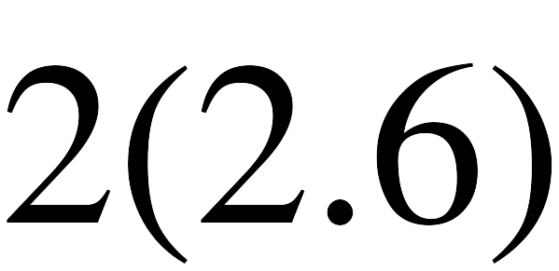
b. (1) | 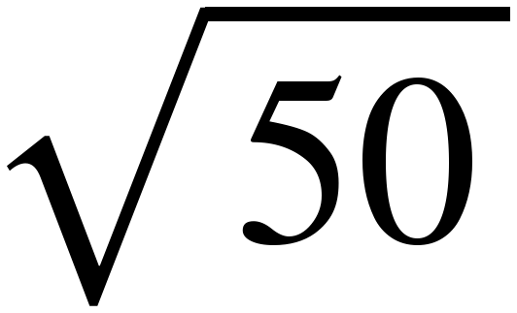 | < > = | 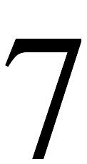
c. (1) | 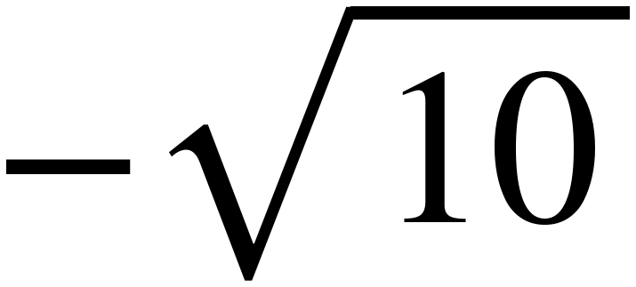 | < > = | 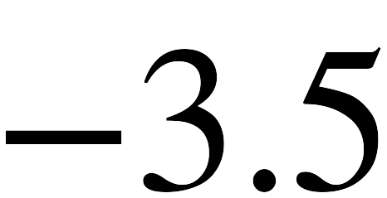
d. (1) | 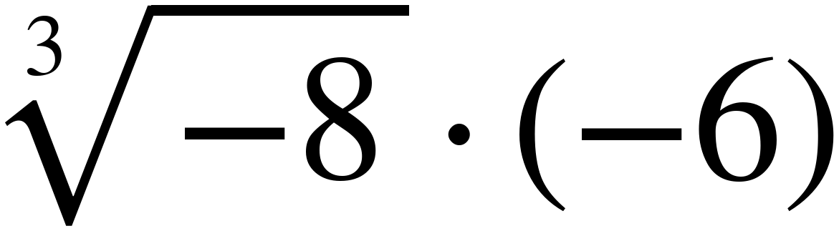 | < > = | 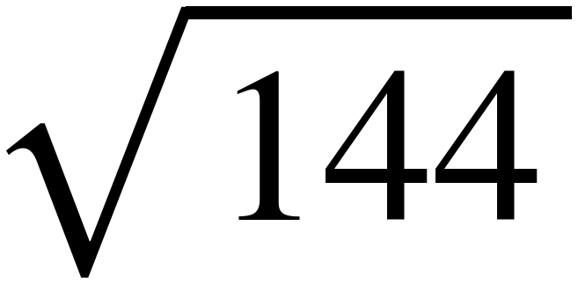
e. (1) | 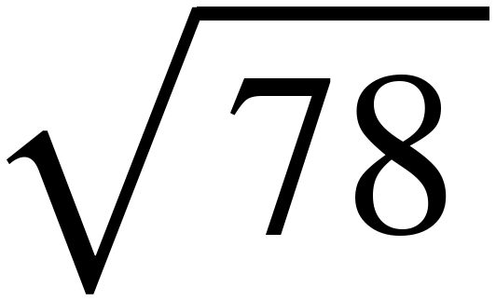 | < > = | 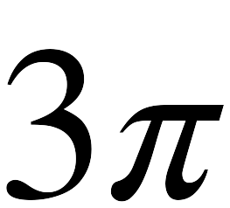

a. 8 − π ≈ 4.86, and 2(2.6) = 5.2.
b. 50 > 49, so √50 > 7. No estimating needed.
c. √10 ≈ 3.2, so −√10 ≈ −3.2, right of −3.5.
d. ∛−8 = −2 and (−2)(−6) = 12. √144 = 12.
e. √78 < √81 = 9, and 3π ≈ 9.42.
Scoring: One point each for a to e = 5 points.
8. Plot and label each value on the number line. | 4 points

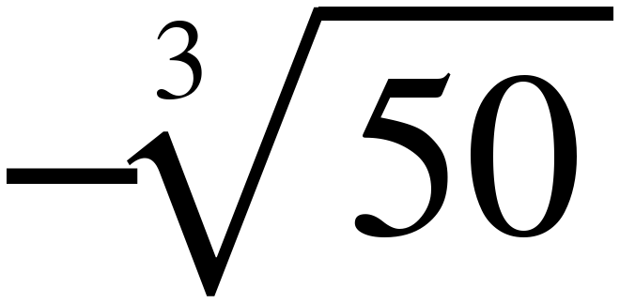 , 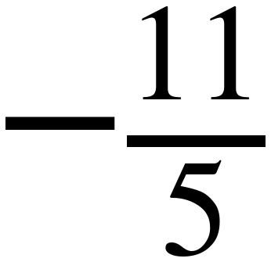 , 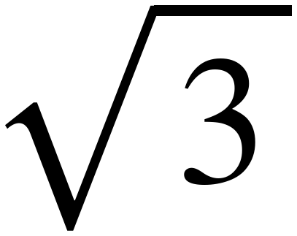 , 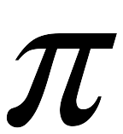
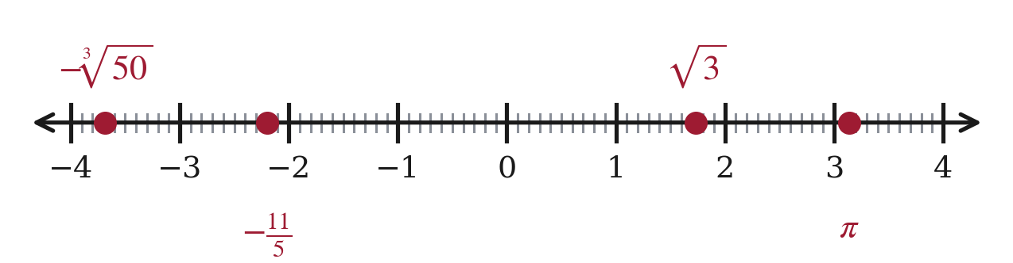
−∛50 ≈ −3.7 (50 sits between 27 and 64, nearer 64). −11/5 = −2.2. √3 ≈ 1.7. π ≈ 3.14. Accept a point within a quarter unit.
Scoring: One point per value plotted and labeled = 4 points.
4. Rational or Irrational | 6 points

9. Write each number in the correct column of the table. | 6 points

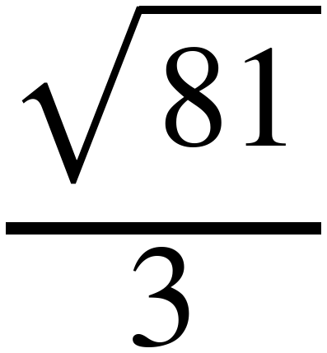 , 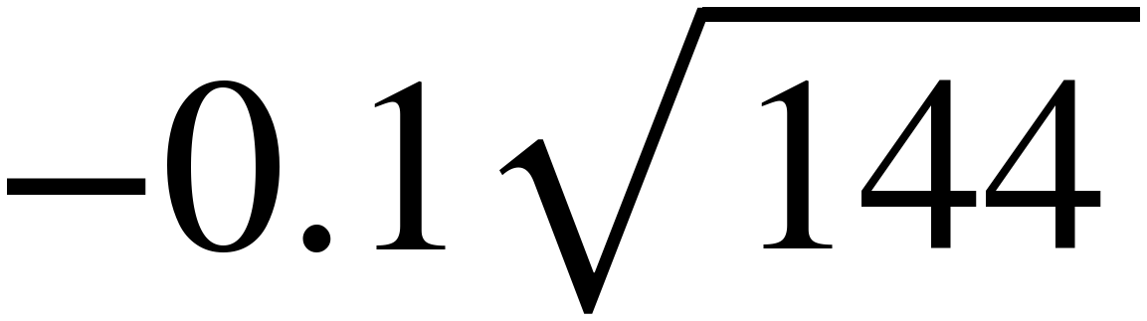 , 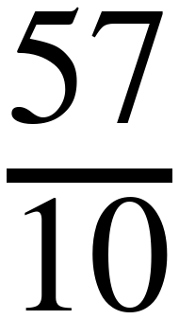 , 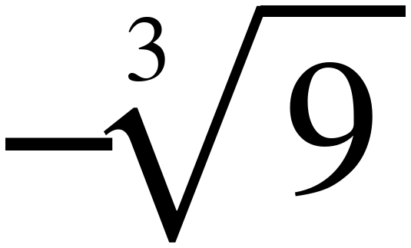 , 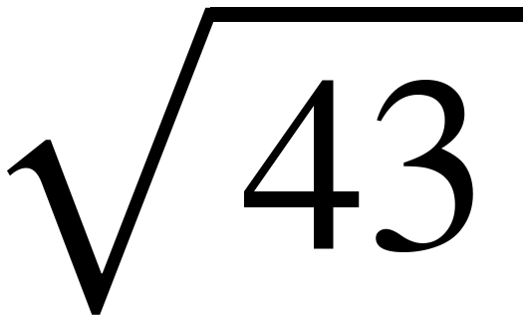 , 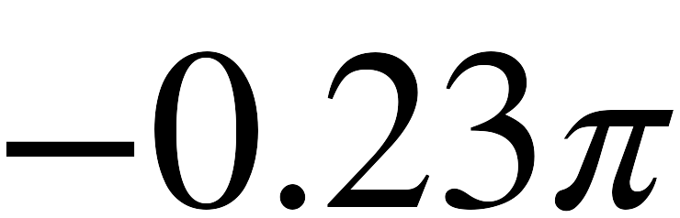
Rational Number | Irrational Number
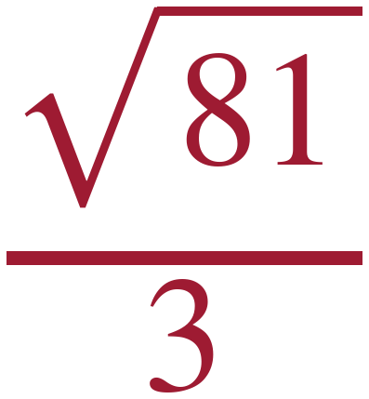 (1)  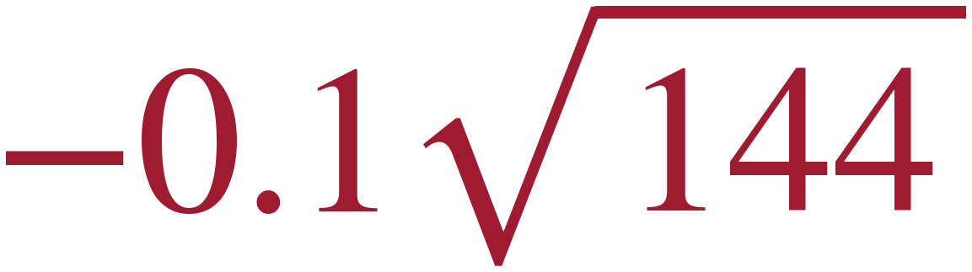 (1)  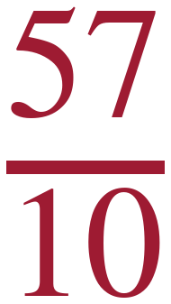 (1) | 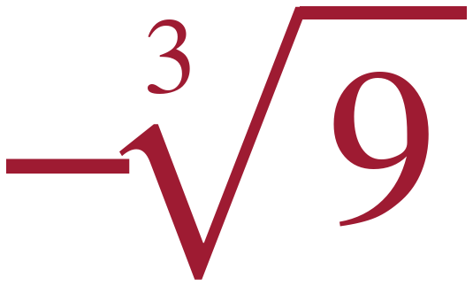 (1)  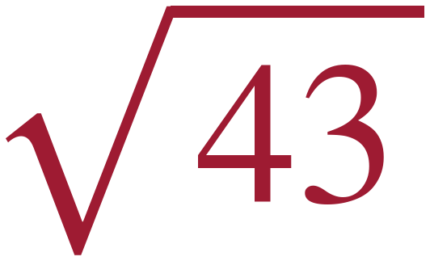 (1)  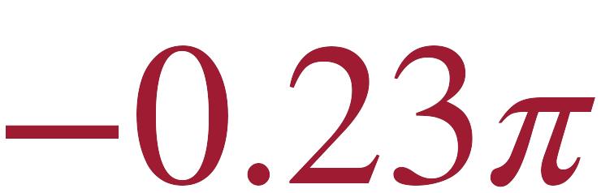 (1)

√81 ÷ 3 = 9 ÷ 3 = 3 — a square root can be rational, and this is the one students most often misplace. −0.1√144 = −1.2. 57/10 = 5.7. 9 is not a perfect cube, so −∛9 is irrational — 9 being a perfect square does nothing for a cube root. 43 is not a perfect square, so √43 is irrational. −0.23π keeps π's irrationality.
Scoring: One point per number, six numbers = 6 points.

Score Tracker
Benchmark | Questions | Possible | Earned
MA.8.AR.2.3 | 3, 4, 5 | 11
MA.8.NSO.1.1 | 1, 2, 9 | 13
MA.8.NSO.1.2 | 6, 7, 8 | 10
Total |  | 34
34 items, one point each. Sections: 1 — 7 · 2 — 11 · 3 — 10 · 4 — 6.
Follow-through. If a student writes the wrong equation or inequality in one part and then works their own answer correctly in the next, the next part still earns its point. Mark the second part against what they wrote, not against the key.

